Barcode pull-through reading devices

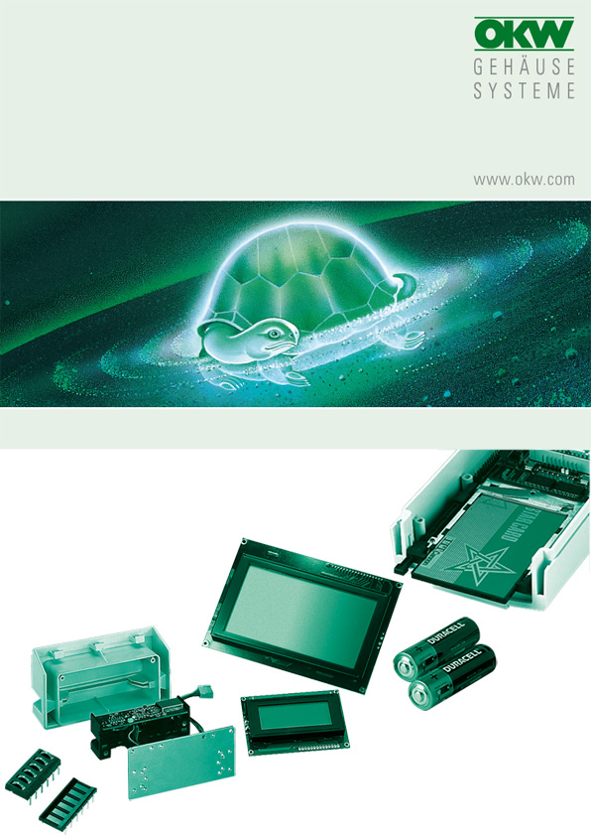

FOR DATEC-TERMINAL M, L

The units are almost identical with the pull-in readers for magnetic cards. They thus fit into the specially designed lids with slot, B 40 30 917 (DATEC-TERMINAL L) and B 40 16 917 (DATEC-TERMINAL M).

For installation, a suitable hole must be milled in the lid. With the help of mounting plate B 41 16 136, which is available as an accessory, the readers can then be screwed into the lid.

Manufacturer |  | Source of supply |  | Type/ designation
AceProx |  | AceProx Identifikationssysteme GmbH  Bahnhofstraße 73  D-31691 Helpsen  Phone +49 (0) 5724 / 98360  Fax +49 (0) 5724 / 98361  info@aceprox.de  www.aceprox.de |  | BCR150B  BCR200  BCR180

No responsibility is taken for the correctness of this information.

Odenwälder Kunststoffwerke
Gehäusesysteme GmbH
Friedrich-List-Str. 3
74722 Buchen/Germany
www.okw.com

