Barcode scanner

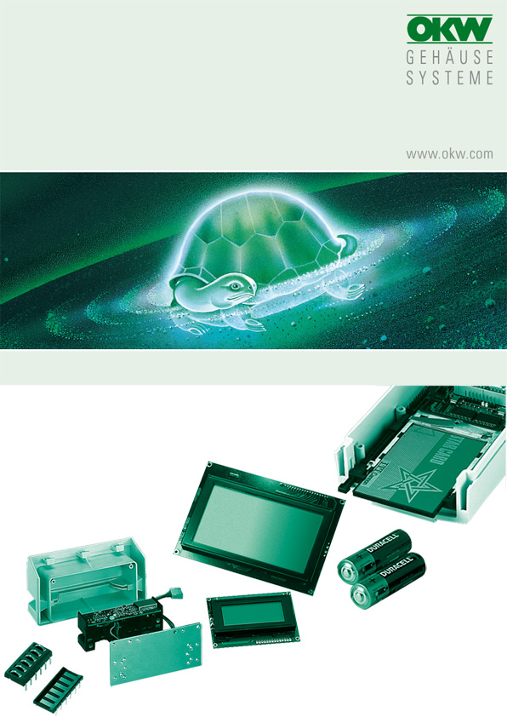

FOR DATEC-CONTROL XS

For further information, here is the web address of the manufacturer: microscan.com or smallscanners.com. Data sheets are also available in German there (pdf).

Installation: not tested.

Manufacturer |  | Source of supply |  | Type/ designation
Microscan |  | OPAL Associates GmbH  Lohnerhofstr. 2  78467 Konstanz  Phone: +49 (0) 7531 / 813 00 0  Fax: +49 (0) 7531 / 813 00 99  info@opalgmbh.de  www.opalgmbh.de |  | MS-3 Laser  MS-3 CCD  MS-3 Engine

No responsibility is taken for the correctness of this information.

Odenwälder Kunststoffwerke
Gehäusesysteme GmbH
Friedrich-List-Str. 3
74722 Buchen/Germany
www.okw.com

