MAGNETIC CARD READING SYSTEM

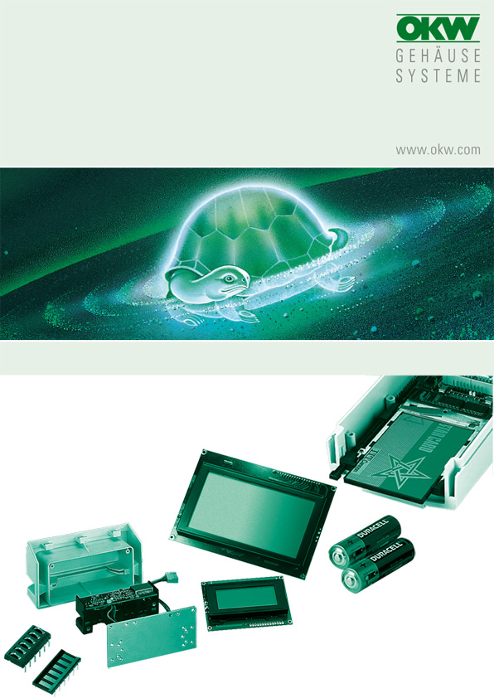

FOR DATEC-TERMINAL M (B 40 16 917)

All of the magnetic card reading systems shown in the list can be built into the lid with a slot. When ordering, please specify the exact type designation so that the correct slots can be milled in the lid. The mounting plate Part-No. B4116136 is essential for the installation of the reader.

The screws for securing the reading systems to the mounting plate are not included in the scope of delivery. To install the reader supplied by the company VF-Feintechnik GmbH, two additional holes must be drilled in the mounting plate.

Manufacturer |  | Source of supply |  | Type/ designation
OMRON Japan |  | CELCO electronic GmbH  Dr.-Schoenemann- Straße 40  D-66123 Saarbrücken  Phone +49 681 638083  Fax +49 681 638084 |  | all HNR...types  (AS051780)  all HSR...types  (AS051780)  all HBR...types  (AS051780)  all HBR./S types  (AS051780)
Hopt+Schuler Germany |  | DDM  Hopt+Schuler GmbH  Heerstraße 44  D-78628 Rottweil  Phone +49 741 26070  Fax +49 741 13398  ddm@hopt-schuler.com  www.hopt-schuler.com |  | 832 009  (AS051780)  832 010  (AS051779)
MAGTEK |  | Mag-Tek Europe  25-26 Shrivenham Hundred Business Park  Watchfield  Swindon SN6 8TZ  Phone +44 1793 786070  Fax +44 1793 786076  sales@magtek.co.uk  www.magtek.co.uk |  | 210450xx
PANASONIC Japan |  | DATA MODUL AG  Landsberger Straße 322  D-80687 München  Phone +49 89 56017 0  Fax +49 89 56017 119  info@data-modul.de  www.data-modul.de |  | ZU-M1121..20..  (AS051835)  ZU-M1131..10..  (AS051780)  ZU-M**** 5  (AS051779)
VF-Feintechnik GmbH  Germany |  | VF-Feintechnik GmbH  Unt. Brunnengasse 3  D-97353 Wiesentheid  Phone +49 9383 7585  Fax +49 9383) 77 95  VF-Feintechnik@t-online.de  www.vf-feintechnik.de |  | D-02 110 000  D-02 011 000  D-02 111 000

No responsibility is taken for the correctness of this information.

Odenwälder Kunststoffwerke
Gehäusesysteme GmbH
Friedrich-List-Str. 3
74722 Buchen/Germany
www.okw.com

