CONTACTS

For transmitting charging current and data flow

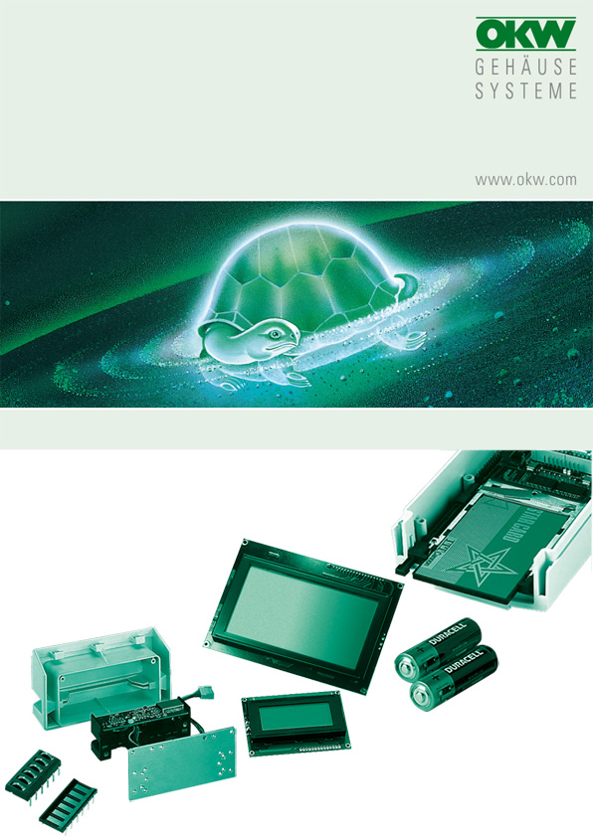

FOR DATEC-CONTROL / ERGO-CASE

Definition of Part-Nos. from Bourns

70AD | model number (please quote in all correspondence)
H | with soldering post (through-hole)
00X | for X please specify the required number of contacts,  available with 2, 3, 4, 5 and 6 contacts
M bzw. F | gender, M stands for male, F for female
L | Low profile
0 bzw. 1 | 0 = standard version without antirotation device  1 = version with two pins as antirotation device

The centring devices in the case and the station are drilled to Ø 1 mm, the soldering posts of the contacts are pushed through the holes, bent round the inside of the case, station or wall suspension element, and if necessary are soldered to the connecting cables. Wall suspension element is without centring devices (openings already available). For version 1 with two pins as antirotation device, additional drillings are necessary for the assembly. The contacts are available in 2, 3, 4, 5 and 6-pin versions.

Part-Nos. OKW
- A9178007, male, 6-poles without antirotation device
- A9178008, female, 6-poles without antirotation device

Recommended for
DATEC-CONTROL M/L with station
See assembly instruction www.okw.com.
The opening in the case/base is intended for the 6-pin version, but all others fit as well.
For DATEC-CONTROL XS/S enclosure sets are available, consist of 1 enclosure with machining, 1 station,
1 contact 6-pins male (station) and 1 contact 6-pins female (enclosure).
ERGO-CASE with wall suspension element
See assembly instruction www.okw.com.
The opening in the wall suspension element is intended for the 6-pin version, but all others fit as well.

Manufacturer |  | Source of supply |  | Type
BOURNS |  | European Headquarter:  BOURNS AG  Zugstr. 74  CH-6340 Baar  T +41 41 7685555  F +41 41 7685510  eurotech@bourns.com  www.bourns.com |  | Modular Contact Model 70AD H - 00X - M L 0  (male for station)  Modular Contact Model 70AD H - 00X - F L 0  (female for enclosure)

Odenwälder Kunststoffwerke
Gehäusesysteme GmbH
Friedrich-List-Str. 3
74722 Buchen/Germany

